Title in English
Title in Spanish
Title, first and last name of the author.
Email
Affiliation
https://orcid.org/0000-0003-2794-6161

APA 7th edition citation: (do not edit)

Received: | Accepted: (do not edit)

Abstract
(200 words maximum)

Keywords: (3 to 5 words)

Resumen
(200 words maximum)

Palabras clave: (3 to 5 words)

1. Introduction
Paragraphs must use 1.0 line spacing. They should begin with a tab indent, as shown in this example. Keep the font Arial at 10 pt. Paragraphs should be at least 5 lines long, and each paragraph is recommended to include at least two references in APA 7th edition format, properly argued and paraphrased. You may close this section by stating the objective, hypothesis, or research questions to be addressed. Justify the text.

2. Literature Review
Priority is given to citing authors from the last 5 years of study, while also considering classic authors and long-standing references when the study requires it. Every author cited must appear in the references section. The use of AI is permitted to improve the text, but not to create it in its entirety. In this section you may use tables and color or black-and-white figures as needed. There is no minimum or maximum length, provided it covers all the arguments needed to theoretically justify your research.

3. Methodology
You may use numbered subsections such as 3.1 in italics. Here you should describe the population and sample, the type of research, the research model, how the instrument was applied, how it was validated, and how the obtained data were analyzed, whether or not software was used, and the ethical approvals for administering surveys or interviews, along with any other details that support your research.

4. Results
In this section, the researcher(s) should describe all the most relevant results obtained from their research. You may add tables or figures that are cited in the text. You may use numbered subsections such as 4.1 in italics as needed.

Table 1. Sample description
Note. Xxxxxxx (optional)

Figure 1. Predictive and explanatory studies
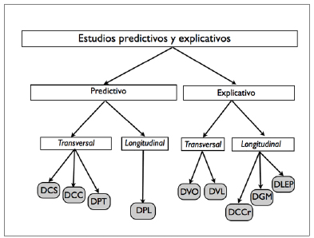
Note. Xxxxxxx (optional)

5. Discussion
This is one of the most relevant sections in a research study, as it is where the authors contrast the results obtained against the general literature, as well as their own informed judgment. Do not forget to cite the authors mentioned in the literature review section, or new ones if you consider it necessary.

6. Conclusions and limitations
Conclude your research by offering the necessary and responsible reflections on what you honestly believe you were able to achieve. Likewise, detail the limitations that typically arise in a study.

7. Future research
Describe here the research that you believe could stem from this article and its contributions to the academic scientific community.

8. References
Below are four reference models en APA 7th edition style, corresponding to the source types most commonly used in scientific articles.
Journal article with DOI
Last name, A. A., Last name, B. B., & Last name, C. C. (Year). Title of the article. Journal Name, volume(número), xx–xx. https://doi.org/xxxxx
Example:
Davis, F. D. (1989). Perceived usefulness, perceived ease of use, and user acceptance of information technology. MIS Quarterly, 13(3), 319–340. https://doi.org/10.2307/249008
Book
Last name, A. A. (Year). Title of the book (edition, if applicable). Publisher.
Example:
Creswell, J. W., & Creswell, J. D. (2023). Research design: Qualitative, quantitative, and mixed methods approaches (6th ed.). SAGE Publications.
Book chapter
Last name, A. A. (Year). Title of the chapter. In A. Editor & B. Editor (Eds.), Title of the book (pp. xx–xx). Publisher. https://doi.org/xxxxx (if it has a DOI)
Example:
Venkatesh, V. (2022). Technology adoption in organizations. En M. Smith & J. Brown (Eds.), Handbook of information systems research (pp. 85–104). Springer.
Web page
Author or organization. (Year, Month day). Title of the page. Website name. URL
Example:
American Psychological Association. (2023). APA style introduction. APA Style. https://apastyle.apa.org
9. Appendices
This section is optional. If you have anything to add, remember to number it and to have cited it in the text of the article.

